**HTML Video**

The <video> element in HTML is used to add video content to web pages. It supports various video formats, including MP4, WebM, and Ogg. Video and audio tags are introduced in[HTML5.](https://www.geeksforgeeks.org/html5-introduction/)

**Syntax:**

<video src="" controls> </video>

* The **[src attribute](https://www.geeksforgeeks.org/html-src-attribute/" \t "_blank) s**pecifies the URL of the video file.
* The [controls attribute](https://www.geeksforgeeks.org/html-controls-attribute/) adds default video controls (play, pause, volume, etc.).

<html>

<body>

  <video width="320" height="240" controls>

    <source src="video.mp4" type="video/mp4">

    Sample Vedio

  </video>

</body>

</html>

**Output:**

**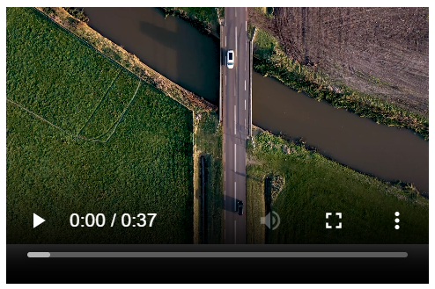**

* The <video> tag defines the video player, with width and height attributes setting its dimensions.
* The controls attribute adds playback controls like play, pause, and volume.

**HTML Video Tags**

Here are the HTML tags used for adding video content:

* **<video>:** Defines a video or movie on a webpage.
* **<source>:** Specifies multiple media resources for video or audio elements (e.g., different video formats).
* Adds text tracks (like subtitles or captions) to a video or audio element.

**Additional Attributes**

|  |  |
| --- | --- |
| **Attributes** | **Description** |
| [**Autoplay**](https://www.geeksforgeeks.org/html-video-autoplay-attribute/) | Starts playing the video automatically. |
| [**Preload**](https://www.geeksforgeeks.org/html-video-preload-attribute/) | Provides a hint to the browser about the best user experience. |
| [**Loop**](https://www.geeksforgeeks.org/html-video-loop-attribute/) | Automatically loops the video. |
| [**height**](https://www.geeksforgeeks.org/html-video-height-attribute-2/) | It sets the height of the video in CSS pixels. |
| [**width**](https://www.geeksforgeeks.org/html-video-width-attribute/) | It determines the width of the video display area on the web page. |
| [**Controls**](https://www.geeksforgeeks.org/html-video-controls-attribute/) | It shows the default video controls like play, pause, volume, etc. |
| [**Muted**](https://www.geeksforgeeks.org/html-video-muted-attribute/) | Mutes the audio. |
| [**Poster**](https://www.geeksforgeeks.org/html-video-poster-attribute/) | Displays an image preview before video loading. |

**More Examples of HTML video**

**Responsive Video with Poster Image**

<html>

<head>

  <style>

    video {

      max-width: 100%;

      height: auto;

      display: block;

      margin: 0 auto;

    }

  </style>

</head>

<body>

  <video controls poster="https://via.placeholder.com/640x360.png?text=Video+Loading">

    <source src="video.mp4" type="video/mp4">

  </video>

</body>

</html>

**Output:**

**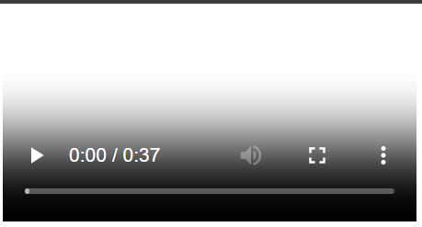**

* The video is made responsive with CSS, adjusting its width to 100% of its container while maintaining the aspect ratio.
* The [poster attribute](https://www.geeksforgeeks.org/html-video-poster-attribute/) displays a placeholder image before the video loads or plays, enhancing the user experience.

**Customized Video Controls with Autoplay and Loop**

<html>

<head>

  <style>

    video {

      width: 640px;

      height: 360px;

      border: 2px solid #4CAF50;

      border-radius: 8px;

      background-color: #000;

    }

  </style>

</head>

<body>

  <video controls autoplay loop muted>

    <source src="video.mp4" type="video/mp4">

  </video>

</body>

</html>

**Output:**

**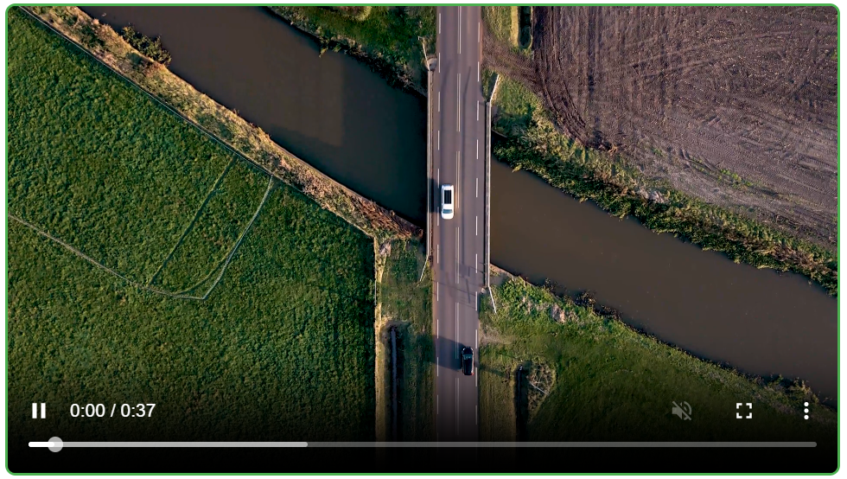**

* The video is styled with a green border, rounded corners, and a black background to enhance its appearance.
* The [autoplay](https://www.geeksforgeeks.org/how-to-add-autoplay-video-in-html/" \t "_blank), loop, and [muted](https://www.geeksforgeeks.org/html-muted-attribute/) attributes ensure the video plays automatically, repeats indefinitely, and starts without sound, respectively.

**Best Practices for HTML <video> Elements**

* **Provide Multiple Formats**: Include various video formats (e.g., MP4, WebM) to ensure compatibility across different browsers.
* **Optimize Video Size:** Compress videos to reduce loading times, enhancing user experience.
* **Use the controls Attribute**: Add playback controls to allow users to play, pause, and adjust volume.
* **Set Appropriate Dimensions:** Define width and height to maintain consistent layout and prevent layout shifts.